PLANO DE AÇÃO

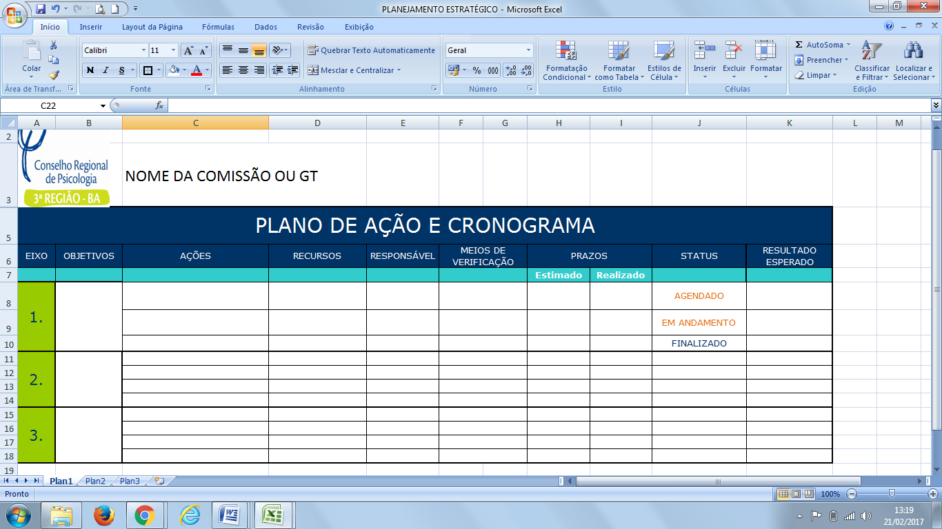

|  |  |  |  |  |  |  |  |  |  |
| --- | --- | --- | --- | --- | --- | --- | --- | --- | --- |
| **1.** |  |  |  |  |  |  |  |  |  |
| **2.** |  |  |  |  |  |  |  |  |  |
| **3.** |  |  |  |  |  |  |  |  |  |